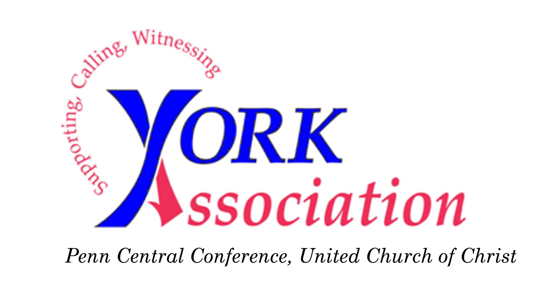

JoAnn Kreeger, President
Rev. Ronald Oelrich, Vice-President
Rev. Katherine Seiler, Secretary
Rev. Robert Brown, Treasurer

To ensure proper posting, please copy and use this form when sending remittances.

Remittances should be made payable to: York Association – UCC

Mail them to our treasurer: Rev. Robert Brown, 1855 Lilac Rd., York, PA 17408-1527.

Remittance from the treasurer of:

Enclosed please find check number dated

in the amount of $________________. This remittance is to be distributed as follows:

Recommended Contribution (Dues) $__________________________

Members in Discernment $__________________________

Hartman Center $__________________________

Work Camp Project $__________________________

Work Camp Scholarship $__________________________

Micro-Lending $__________________________

Local Ministries (e.g. Safe $__________________________
Haven, Mr. Sandy’s)

Other________________ $__________________________

Total remittance $__________________________

If you have any questions concerning your remittance,
please call Rob Brown at 717-764-0091 or email RobBrown73@comcast.net

To be credited for the current year, the Association Treasurer must receive remittances
by December 31.

